Contents

WEBSITE INTERFACE 1

Homepage 1

**Contact Us page** 3

Account page 4

Shopping Cart Functions 5

Endow Page 5

Partner 6

About Page 6

Infomation Security 8

Commitment to satisfaction 8

Complaint inquiries 9

Payment Guide 10

Product Page 10

Product Details 11

Footer 11

**REVIEW 2**

# WEBSITE INTERFACE

## Homepage

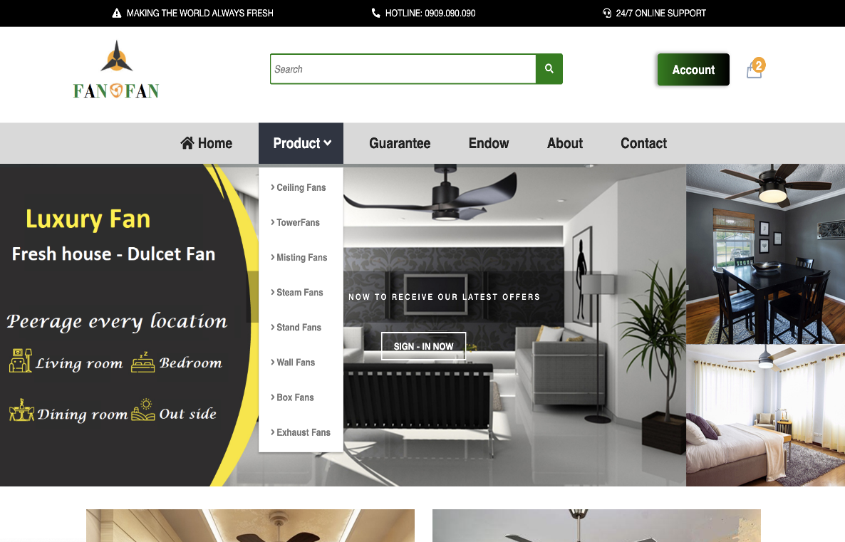

When the user points to the menu bar, a drop-down of submenus of the main menu appears, as you can see in the figure above

|  |  |
| --- | --- |
| **Title** | **Description** |
| Contact us | * Fantofan company address with map, official contact information * Gateway to receive customer feedback |
| Account | * We have a login and account creation program for new customers, customers can track your order at the website. |
| Home | * Introduction to pictures of popular items we have been dealing in for many years. * Some items have high convenience for users. Comfortable, advantageous, Easy to use * The footer mentions necessary information about us such as: Information security, Commitment to satisfaction, Complaint inquiries, Payment Guide |
| About Us | * Board members: One of the leaders in the fan manufacturing industry * Staff Directory: Many years of experience in the home fan industry * Careers: Stable employment according to personal capacity (Leader, Manager) |
| Services | * General Services : Customers can leave your phone number or email, we will advise related issues * Check and design a safe, comfortable installation space suitable for your home * Nominate designs according to customers' opinion and bring the best experience |
| Department | * Help customers find beautiful products suitable for their home * Professional installation personnel department * - Billing and Accounts: Online payment with details. |
| Academics | * Introducing attractive colors for the home to help you have a lively living space, providing a higher quality of life |
| Facility | * We have showrooms so that customers can feel the quality products with their own eyes |

## **Contact Us page**

When you click on "Contact Us Page" you will see a map of the way to our exhibition center

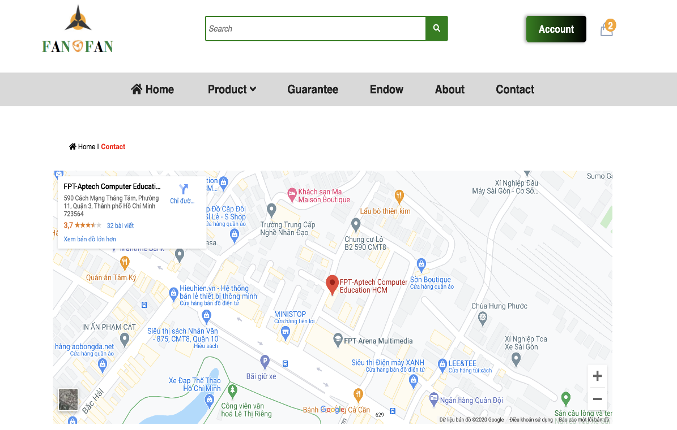

## Account page

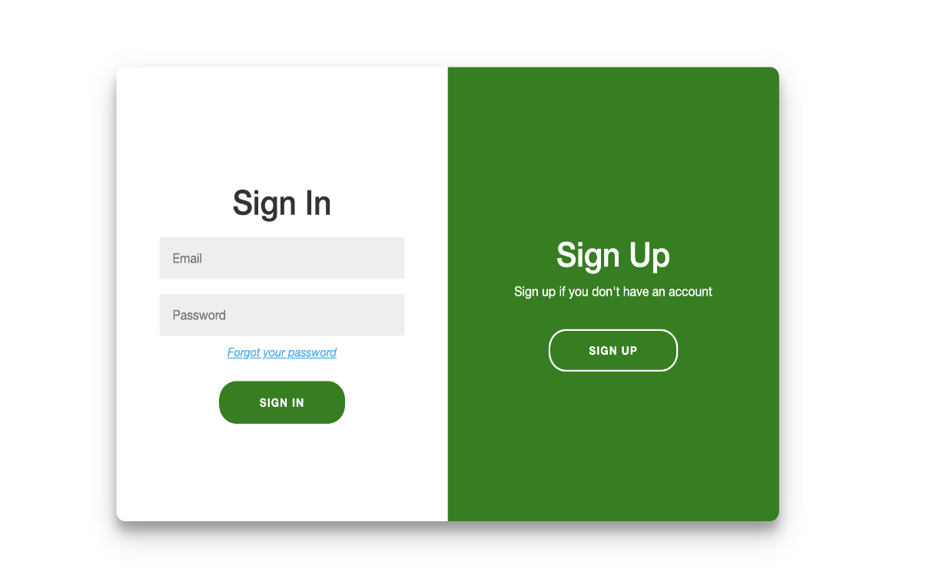

The page is intended for subscribers and login to the personal management page

## Shopping Cart Functions

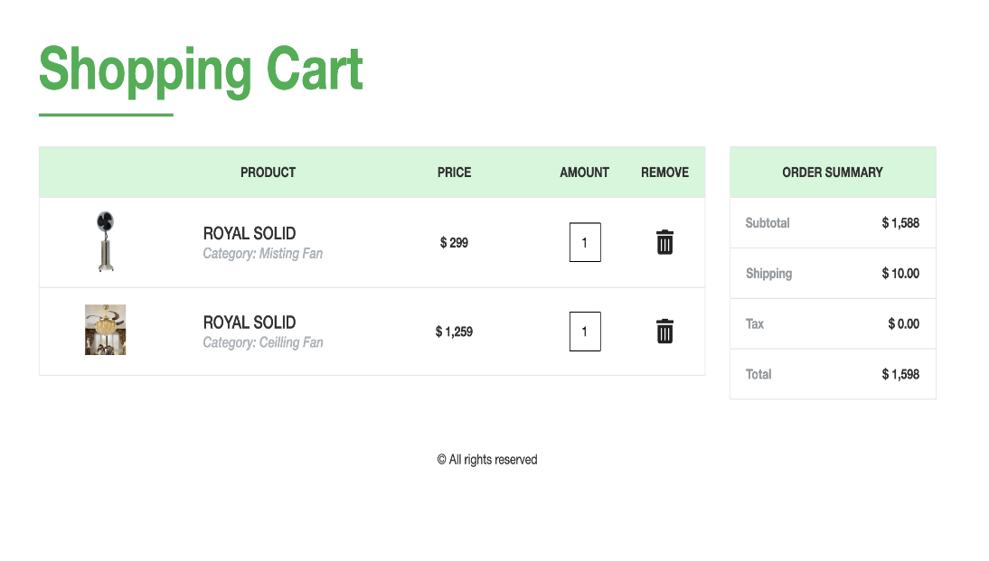

* + Allows customers to choose the quantity
  + See the products you have chosen to buy

## Endow Page



Promotion for customers who purchase at fanofan

## Partner

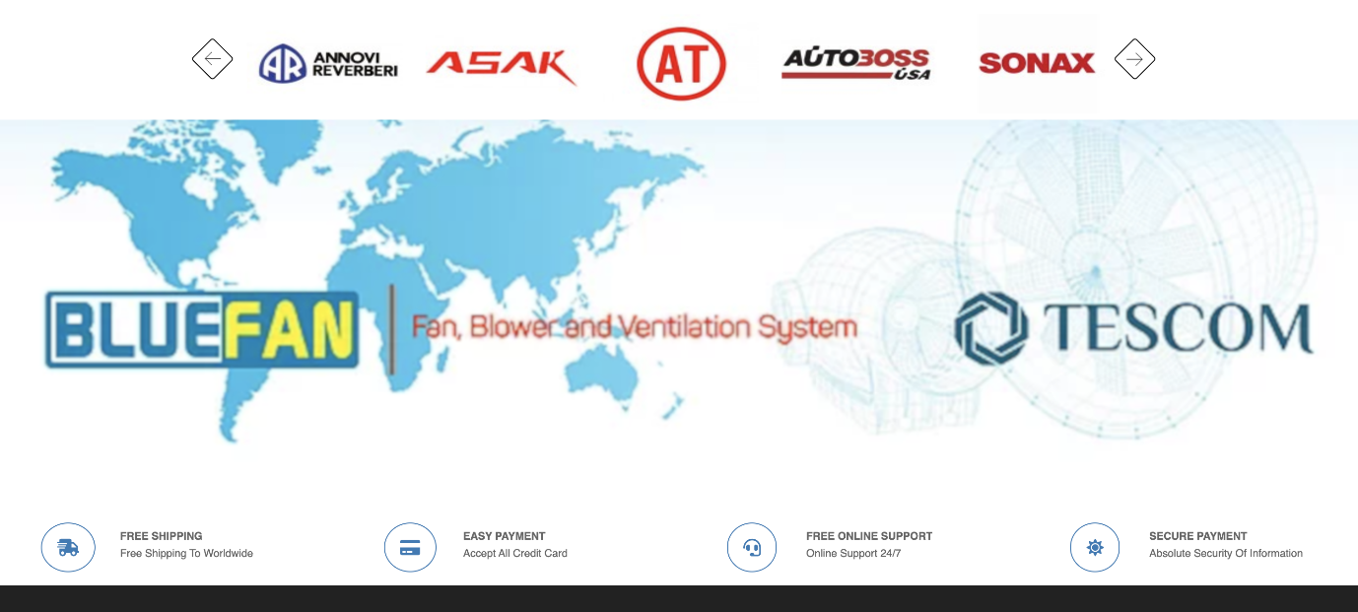

## About Page

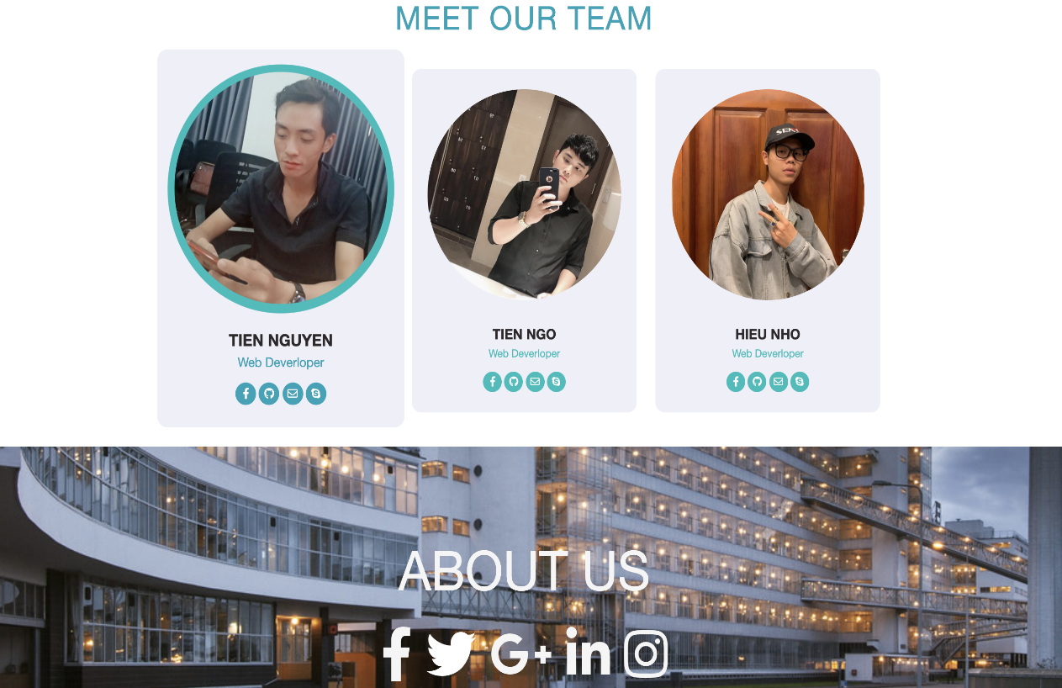

**Feedback page and Query page**

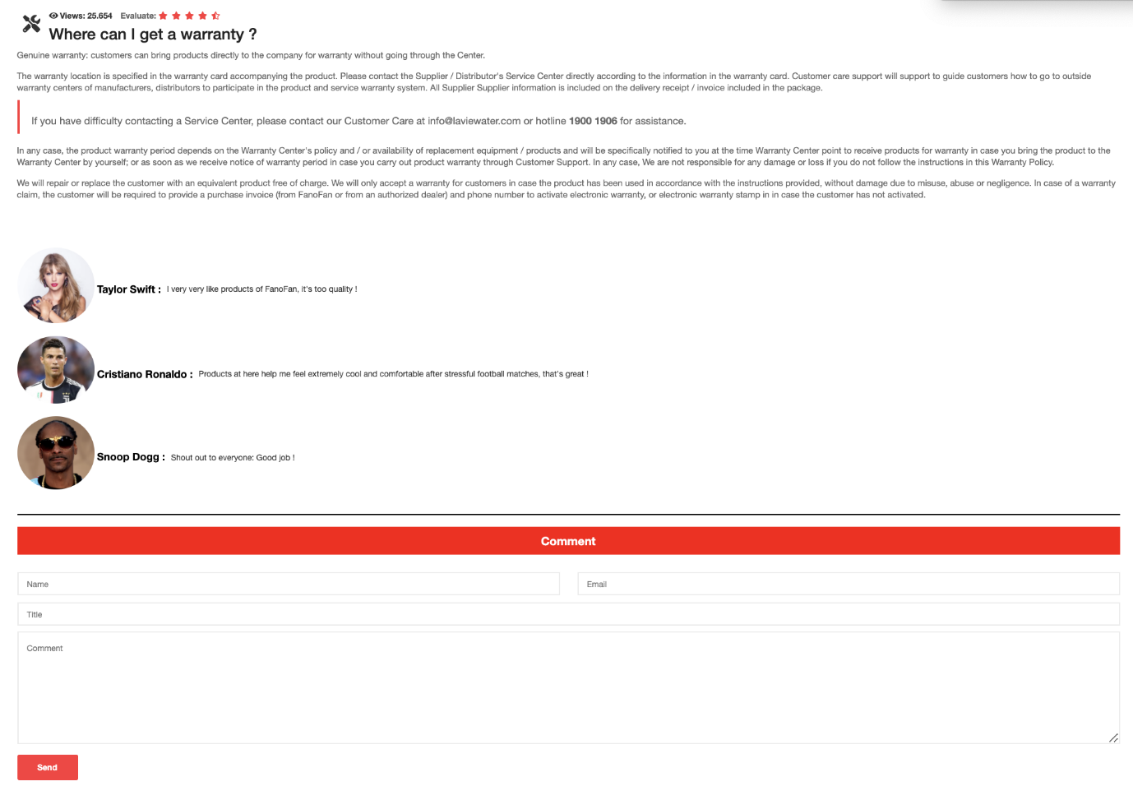  
Customers can give feedback at Customer's Page Feedback page if they want to give their opinion on the quality of products and services.

## Infomation Security

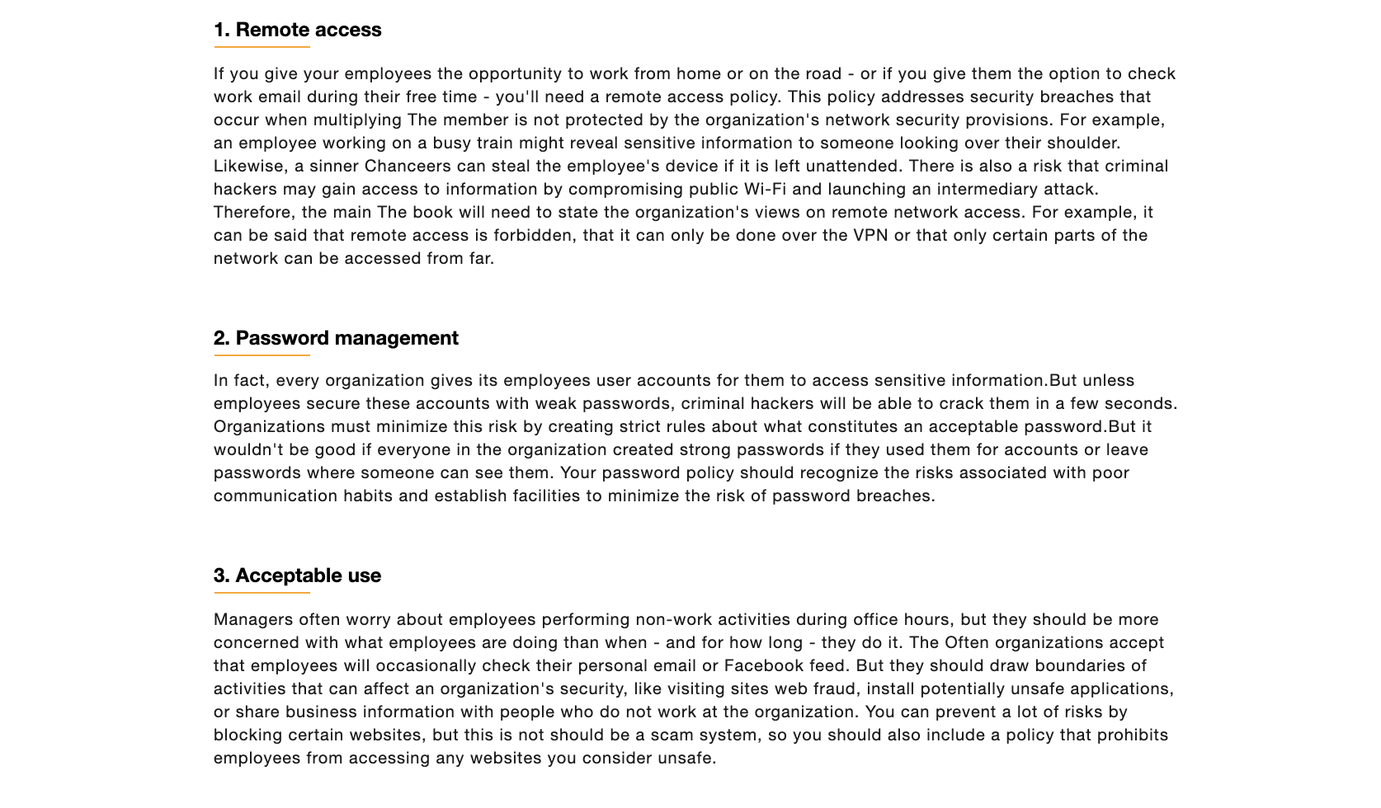

## Commitment to satisfaction

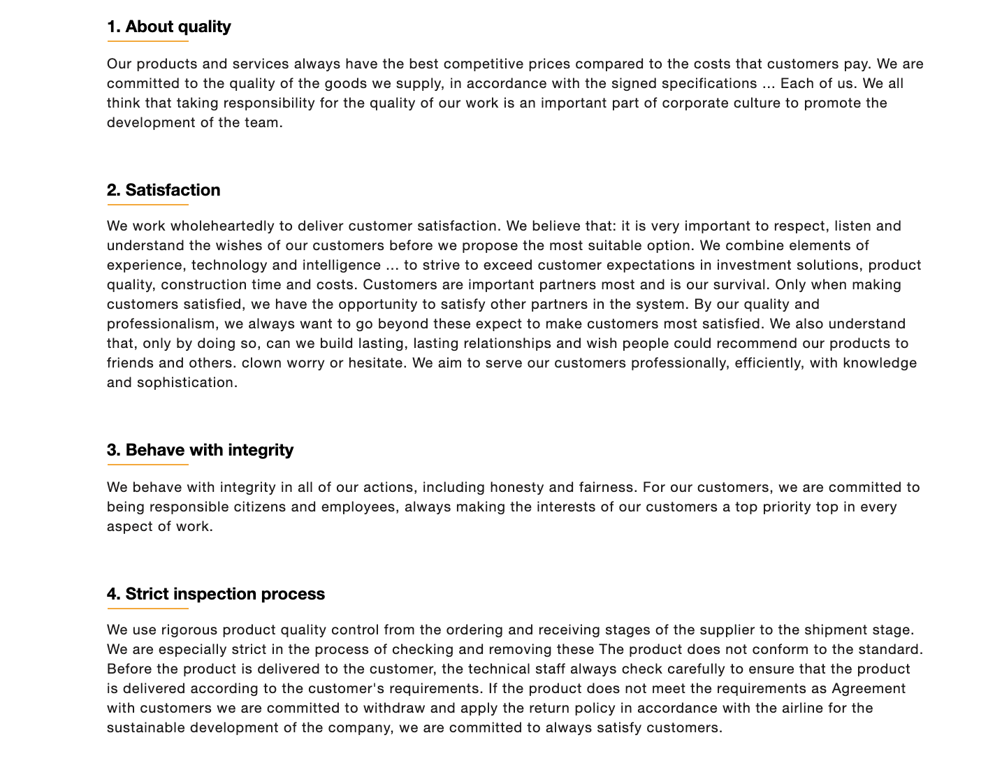

## Complaint inquiries

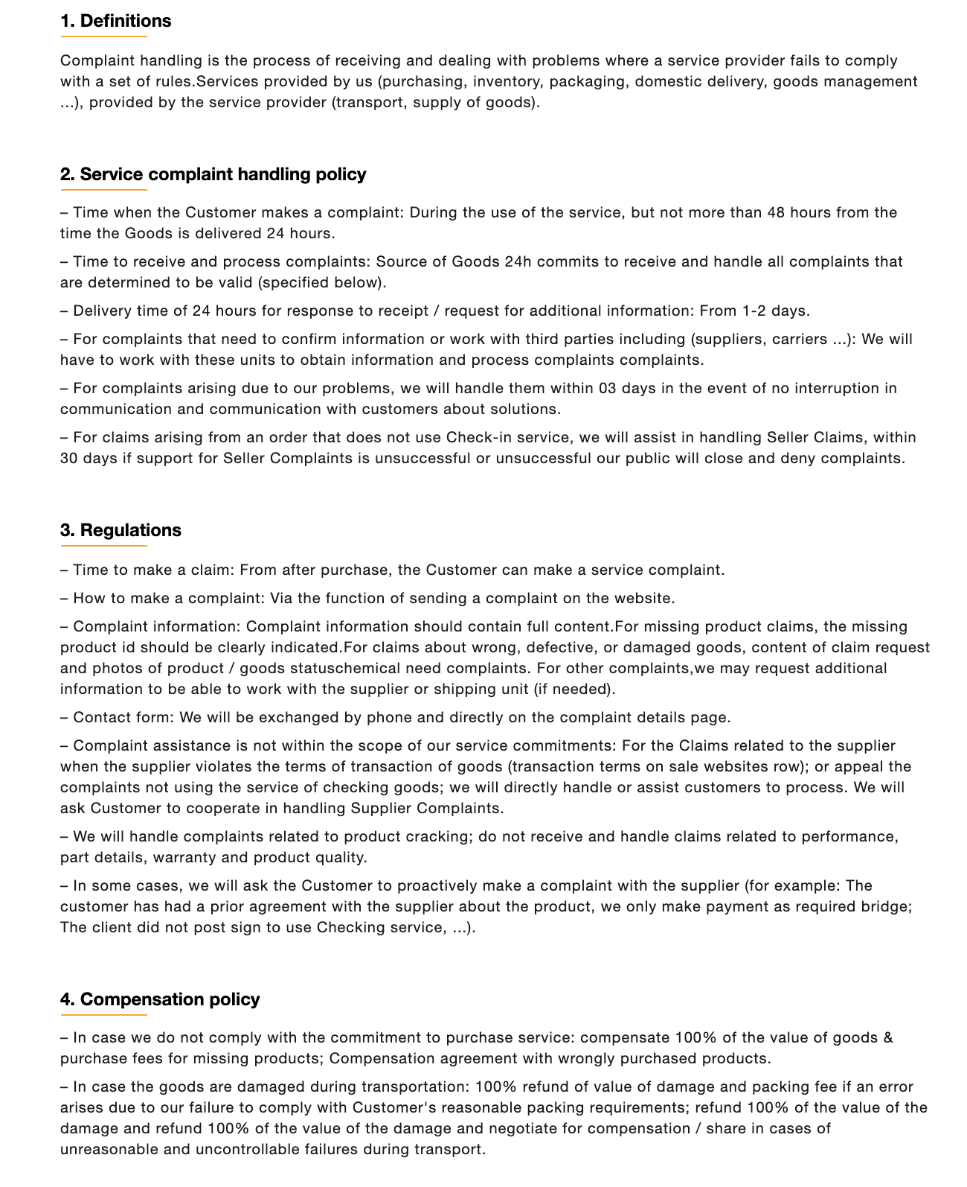

Where to deal with complaints about products and service quality of employees, you can contact the company's phone number, who will be on duty 24/24 to receive your information.

## Payment Guide

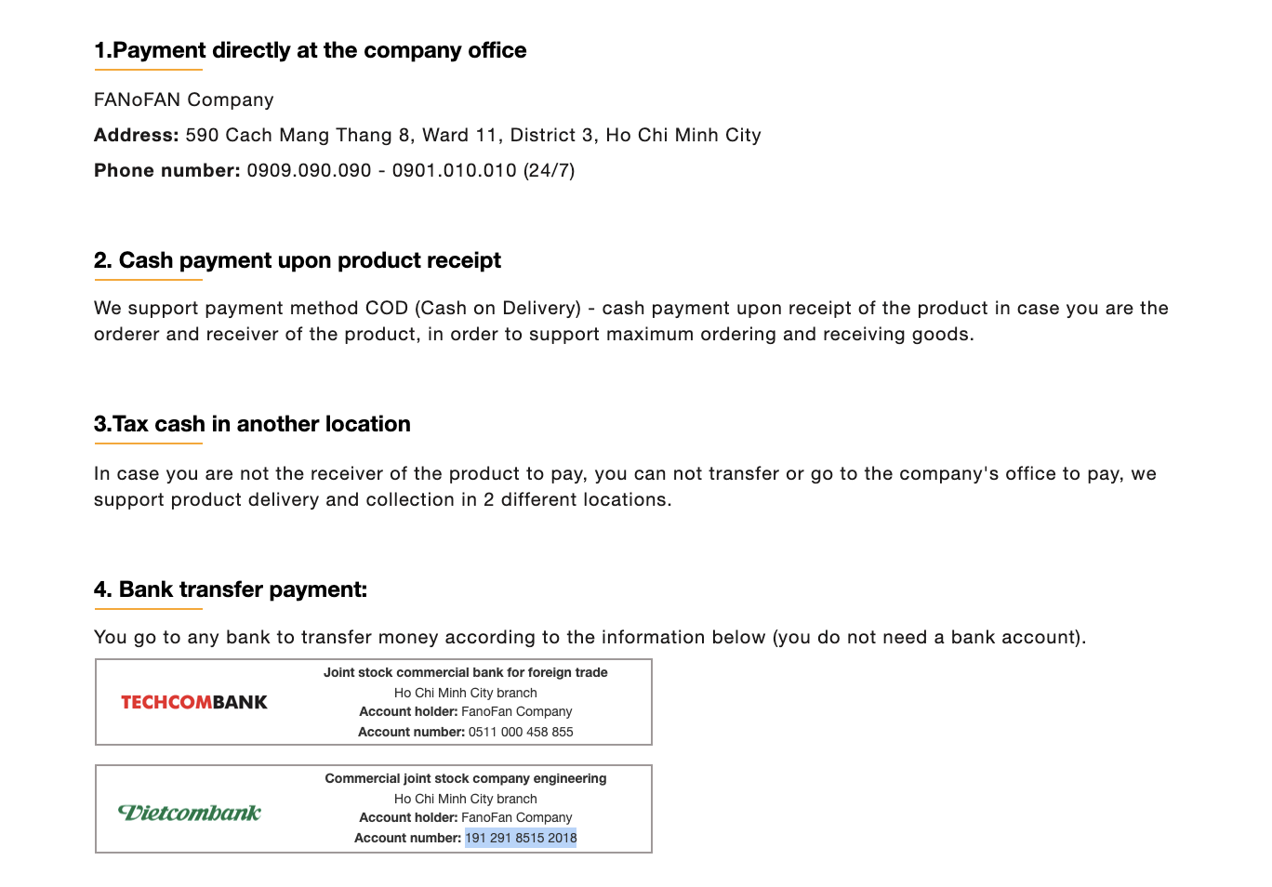

This is the place to guide the payment procedures for customers to pay exactly as the company has set out

## Product Page

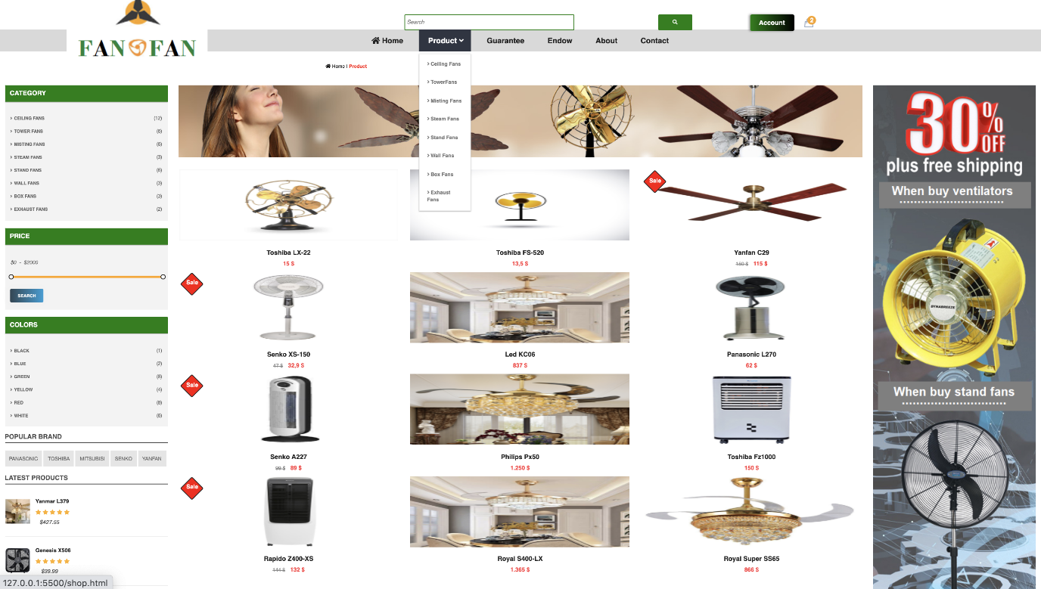

page showing the products of all fan brands

## Product Details

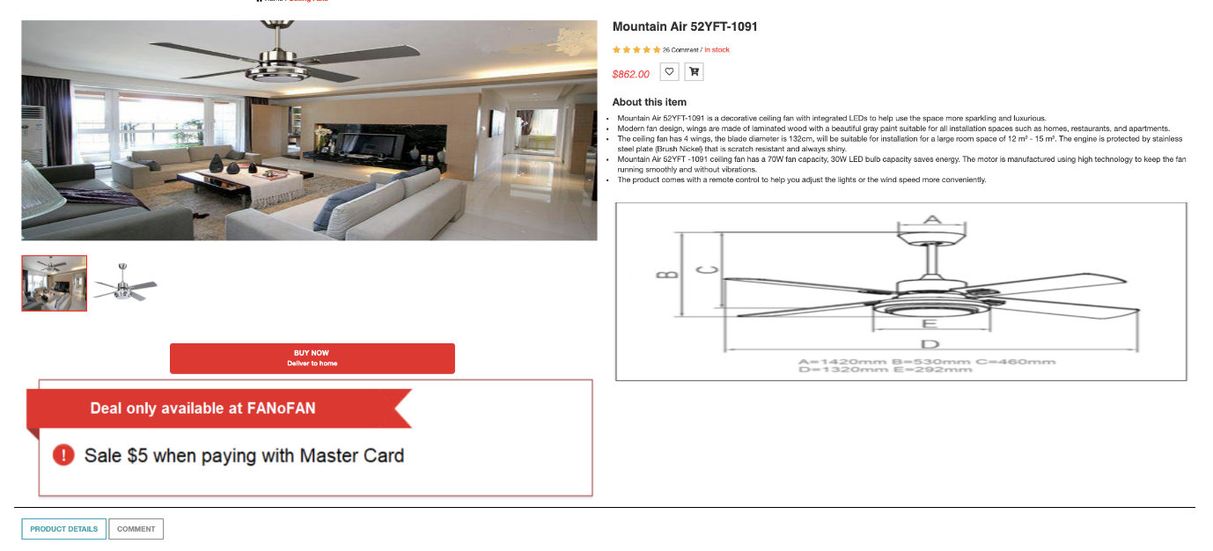

Displays full information about the product such as: Features, place of manufacture, features and specifications

## Footer

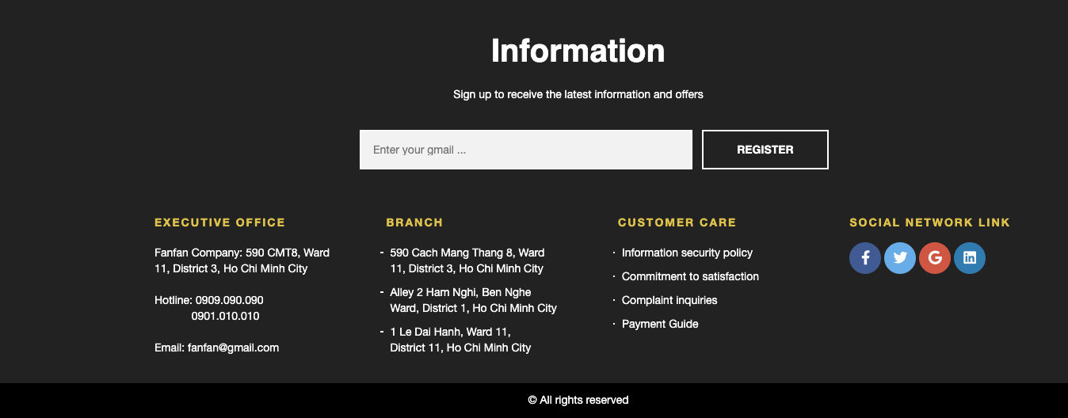

Sign up to receive the latest information and offers

|  |  |  |  |  |  |  |  |
| --- | --- | --- | --- | --- | --- | --- | --- |
| Project Ref. No. | | Project Title | Activity  Plan  Prepared  by | Actual  Start Date | Actual  Days | Team  mate  Names | Status |
| Sr.  No | Task |
| 1 | Design Contact Us  page and coding  (include Geolocation  API) | FanoFan | Tien | 20/10/2020 | 2 | Tien  Tien | Completed |
| 2 | Design Feedback  page, Query page and  coding | FanoFan | Tien | 22/10/2020 | 2 | Tien  Hieu | Completed |
| 3 | Design Account page  and coding | FanoFan | Hieu | 22/10/2020 | 3 | Hieu | Completed |
| 4 | Design About us  pages and coding | FanoFan | Tien | 22/10/2020 | 3 | Tien | Completed |
| 5 | Design Services pages  and coding(Design Image, Thinking ideas) | FanoFan | Tien | 25/10/2020 | 7 | Tien  Hieu  Tien | Completed |
| 6 | Design Department  pages and coding(Billing page, Registration) | FanoFan | Tien | 30/10/2020 | 7 | Tien  Hieu  Tien | Completed |
| 7 | Design Make an  Payment Form(Check out, payment, Shopping Cart) | FanoFan | Hieu | 02/11/2020 | 3 | Tien  Hieu | Completed |
| 8 | Design Product Details | FanoFan | Tien | 02/11/2020 | 3 | Tien | Completed |
| 9 | Design Footer And Menu | FanoFan | Tien | 03/11/2020 | 3 | Tien  Tien | Completed |
| 10 | Group pages together  with links and update  information | FanoFan | Tien | 04/11/2020 | 10 | Tien  Tien  Hieu | Completed |
| 11 | Test website in  different browsers | FanoFan | Tien | 04/11/2020 | 10 | Tien  Hieu  Tien | Completed |

|  |  |
| --- | --- |
| **Signature of Faculty** | **Signature of Leader Team** |
|  |  |